

**EE463**

**STATIC POWER CONVERSION-I**

**Term Project Final Report**

**Distanced Power Solutions Inc.**

***Contributors***

Ceyhun KOÇ 2166833

Defne Nur KORKMAZ 2166858

Görkem GÜLLETUTAN 2166544

Table of Contents

Introduction 4

Project Description 4

Topology Selection 5

Simulation Results 6

1. Simulations of Three Phase Diode Rectifier 6

2. Simulations of Buck Converter 10

3. Simulations of Battery Part 13

Component Selection 15

Capacitors 16

Inductor 16

Diodes 16

MOSFET 17

Shunt Resistor 17

Isolation Op-Amp 17

Digital Isolator 17

Digital Controller 18

Gate Driver 18

Power Conversion Units 19

a. 24V/12V Conversion: 19

b. 24V/3.3V Conversion 19

c. 3.3V Isolation 20

Connectors 20

Heatsink 20

Cost Analysis 21

Power Losses 25

a. Diode Losses 25

• Conduction Losses 25

• Reverse Recovery Losses 25

b. MOSFET Losses 26

• Conduction Losses 26

• Switching Losses 26

c. IC Losses 27

Thermal Analysis 28

a. Diode Thermal Analysis 28

b. MOSFETs Thermal Analysis 29

• High Side MOSFET 29

• Low Side MOSFET 29

Schematic Design 30

a. Rectifier Unit 31

b. Converter Unit 32

c. Isolation Unit 33

d. Logic Unit 34

e. Power Unit 35

f. Connector Unit 35

PCB Design 36

a. Rules and Validations 36

b. 2D Design 38

c. 3D Design 42

d. Conclusion of PCB Design 46

Conclusion 46

References 48

# Introduction

The fact that the energy provided by fossil fuels in the world will be exhausted has directed people to inexhaustible energy resources. That is to renewable energy sources. It is a necessity to focus on renewable energy sources to transfer natural heritage to future generations, to protect the environment and to obtain energy cheaply. For this purpose, three METU EE senior students, named Distanced Power Solutions Inc. presents AC to DC Motor Drive for the wind turbine to get renewable energy.

In this report, we included simulations, power losses, thermal analysis, and PCB design. In the first part of the report, topology selection will be discussed. The advantages and disadvantages of the selected topology will be stated. Also, we will discuss why we selected it. Then, simulation results for ideal cases will be shown. On the other hand, as everyone knows, simulation results are not the same as real-life results. In real life, there are some non-ideal parameters.

In the simulation report, our simulation results were not very good, so we have focused on fixing these results. When we think on this, we have noticed that these results are caused by sample time of the simulation. We have decreased the sample time, and then we have obtained better results. In this report, we included these better results. In the following part, the component selection will be discussed. It will do by adding some margin to what we have measured in the ideal simulation so that the system does not fail. After the simulation report period, for the component selection part, we have made some changes because we have changed our capacitance, inductance, MOSFETs. Also, we have added two heatsinks for the high side and low side MOSFETs. Then, simulation results with the non-ideal parameters of the selected components will be shown. In schematic part we have used Altium Designer 20. In this part, we will show our schematic design which has some parts such as rectifier unit, converter unit, isolation unit, logic unit, power unit and connector unit. Unlike the simulation report, we have also included power losses of diodes, MOSFETs and ICs. Based on power losses, we have made thermal analysis for diodes and MOSFETs. Also, we have added PCB design part to this report.

Our biggest goal from this project is to get a simple, robust, reliable, and as cheap as possible AC to DC converter. We think that this project will improve our practical skills by using theoretical knowledge of EE 463 course. As senior engineering students, this project will give chance us to improve the problem-solving skills that every engineer should have

# Project Description

In this project, we are asked to design an AC to DC converter with the required control techniques to use in the wind turbine. Generated electricity by the turbine will be used to illuminate the road next to our department. There are some specifications and requirements for this project.

Parameters of the synchronous machine are:

* Open circuit voltage peak: 330 Vline-to-line
* Inertia: 0.00027 kg.m2
* Viscous Damping: 0.005024 N.m.s
* Poles: 2
* Voltage Constant: 110 Vl-l /krpm
* Stator Resistance: 10.58 Ohm
* Armature Inductance: 16.7 mH

Project requirements are:

* Battery capacity: 13 Ah
* Battery nominal voltage: 24 V
* Output current: 2 A
* Output current ripple: %20 of average current

# Topology Selection

In this project, we aim to develop a low cost, and compact converter in order to make our design desirable by potential customers. To do that, we have made our topology selection carefully by considering the wieldy usage and reliability of the circuit, and the cost restriction. On the other hand, we work hard for designing efficient and useful converter with this limited budget. For us, there was three different options as a topology that is used on the design.

* Three-phase Thyristor Rectifier
* PWM Rectifier
* Diode rectifier + Buck converter

At the beginning, we discussed about using thyristor diode rectifier in order to rectify the AC signal and regulate it. But in this case, we should consider the firing the gates of all the thyristor diodes in the rectifier. Therefore, we would be dealing with the firing loss, also it would make the circuit complicated instead of our simplicity desire. Also, we want to design a non-bulky hardware to be able to converge to the high class manufacturer. At the end, the thyristor rectifier did not correspond our requirements and it would not satisfy our engineering desires.

Then we considered the PWM rectifier as a topology for our project. In PWM rectifier, the important thing is the switching. Therefore, there will obviously high switching losses besides the conduction losses. Also, we should consider the harmonics of the pulses, there should be filter design in order to suppress the higher harmonics. Thus, we did not want to make our design complicated and we pass through the PWM rectifier option.

As a last and best option for us, we have considered the diode rectifier and buck converter in order to control our 3-phase voltage lines. At first, this option includes the main topics of EE463 lecture, so it will be a good practical application of learning outcomes in the lecture. Also, diode rectifier gives chance to rectify the AC waveforms with minimum amount of conduction and switching losses, we will calculate the losses in the next step of the project. Also, in our design we wanted to keep simple the application and working system. With this simplicity, we can adjust our design in variable current and voltage values as much as they stay in our components’ electrical limitations, current, voltage, slew rate etc.

As a result, we have chosen the diode rectifier and buck converter in our project in order to rectify three-phase waveforms. This topology satisfies our principles in terms of being low budget design, compatible with variable voltage and current values, and easy to control.

# Simulation Results

In this part of the report, simulation results by using MATLAB Simulink with non-ideal cases will be provided. After component selection in the Simulation Report, we implemented the diodes and MOSFETs to Simulink with their real parameters. In the simulation report, we had very noisy current graphs like Figure 1. When we investigate the reason behind it, we see that the sample times were not same for the simulation tool and the components given by the template. After fixing this problem, we have simulated our circuitry and obtained the graph one by one for each subunit.

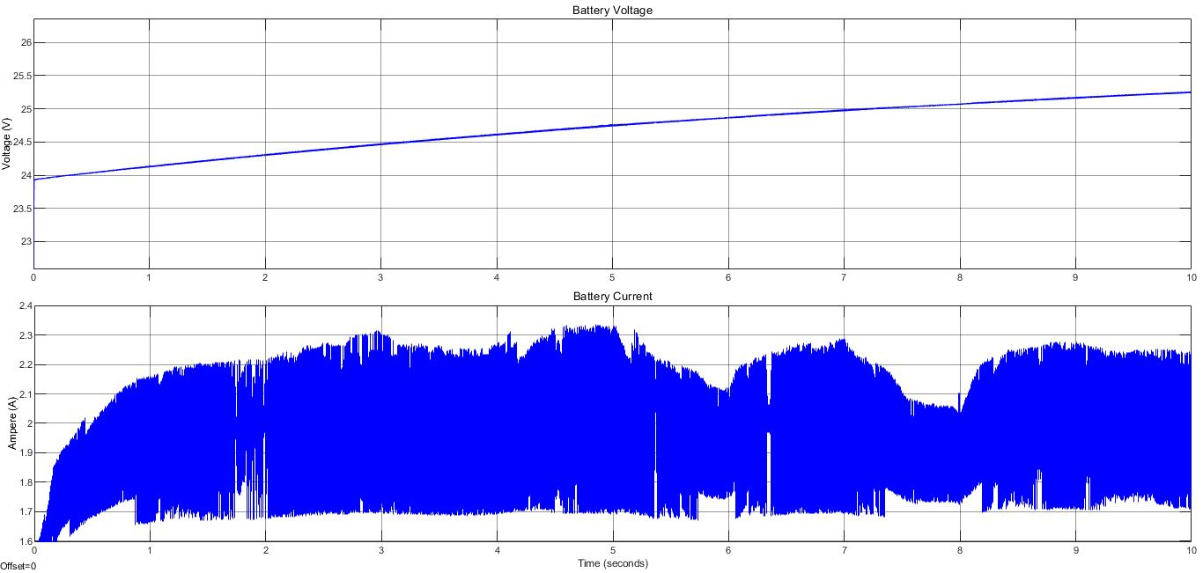

Figure 1 Battery current and voltage from Simulation Report

Firstly, three-phase diode rectifier schematic and simulation results will be shown. Then, the buck converter schematic and simulation results will be observed. After the buck converter, battery, and controller the last part of our system will be shown. Finally, the whole circuit schematic and input-output simulation results of the whole circuit will be provided.

## Simulations of Three Phase Diode Rectifier

As seen in Figure 2 below, in our three-phase diode rectifier circuit, we used a capacitor to filter out output voltage waveform because our input voltage which was given to us for the project is not purely sinusoidal. This simulation does not include line inductance and resistance.

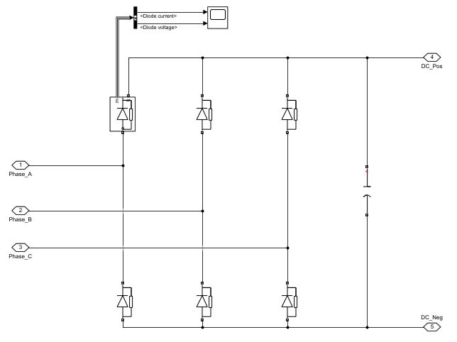

Figure 2 The circuit schematic of three phase diode rectifier

In Figure 3 below, the input line to line and output voltage can be seen for 5 seconds interval (a) and a smaller interval (b) to see the boundaries.

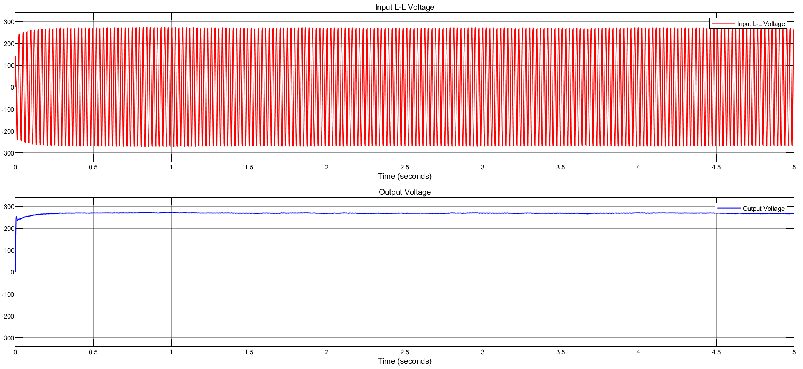

(a)

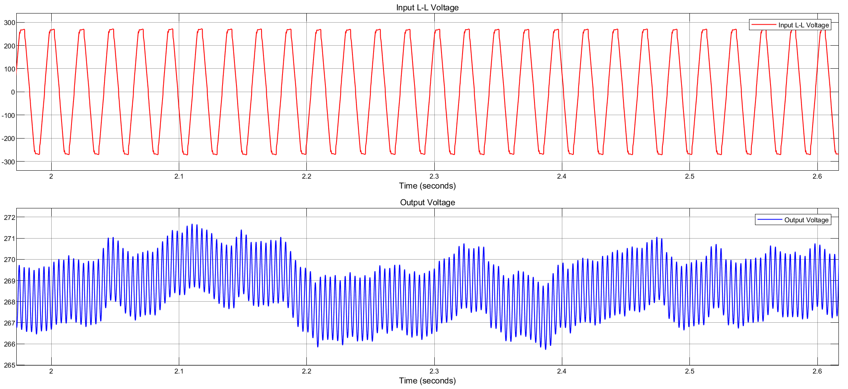

(b)

Figure 3 Rectifier input line to line voltage and rectifier output voltage

We used capacitance with 100μF. If we used a larger capacitance value, we would get a waveform much closer to the DC. On the other hand, this causes to increase in the size and cost of the rectifier. Cost and size are important criteria for our company, so we used this capacitance value to get the optimum balance between efficiency, size, and cost criteria.

In Figure 4 below, input and output current can be observed seen for 5 seconds interval (a) and a smaller interval (b) to see the boundaries.

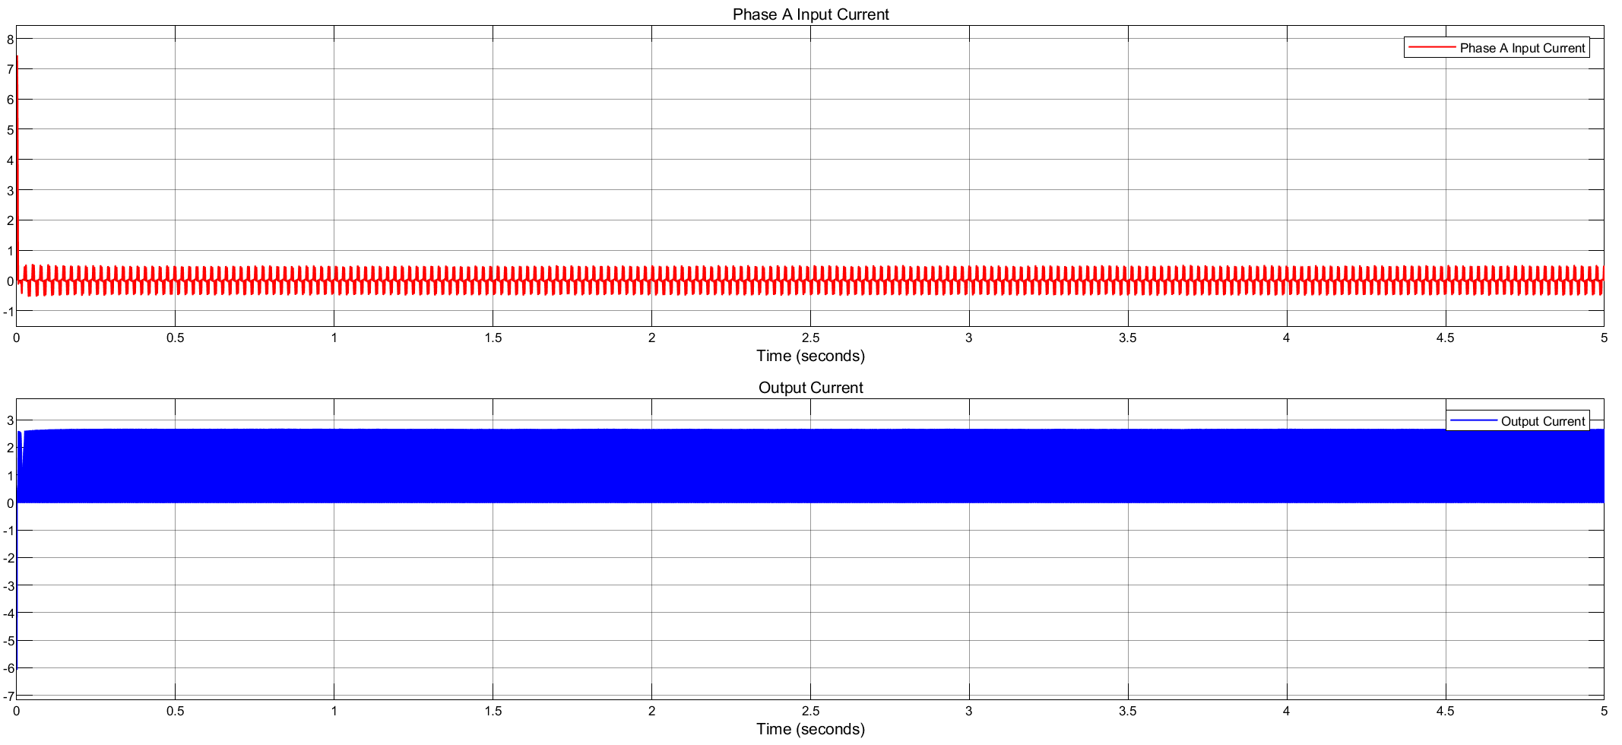

(a)

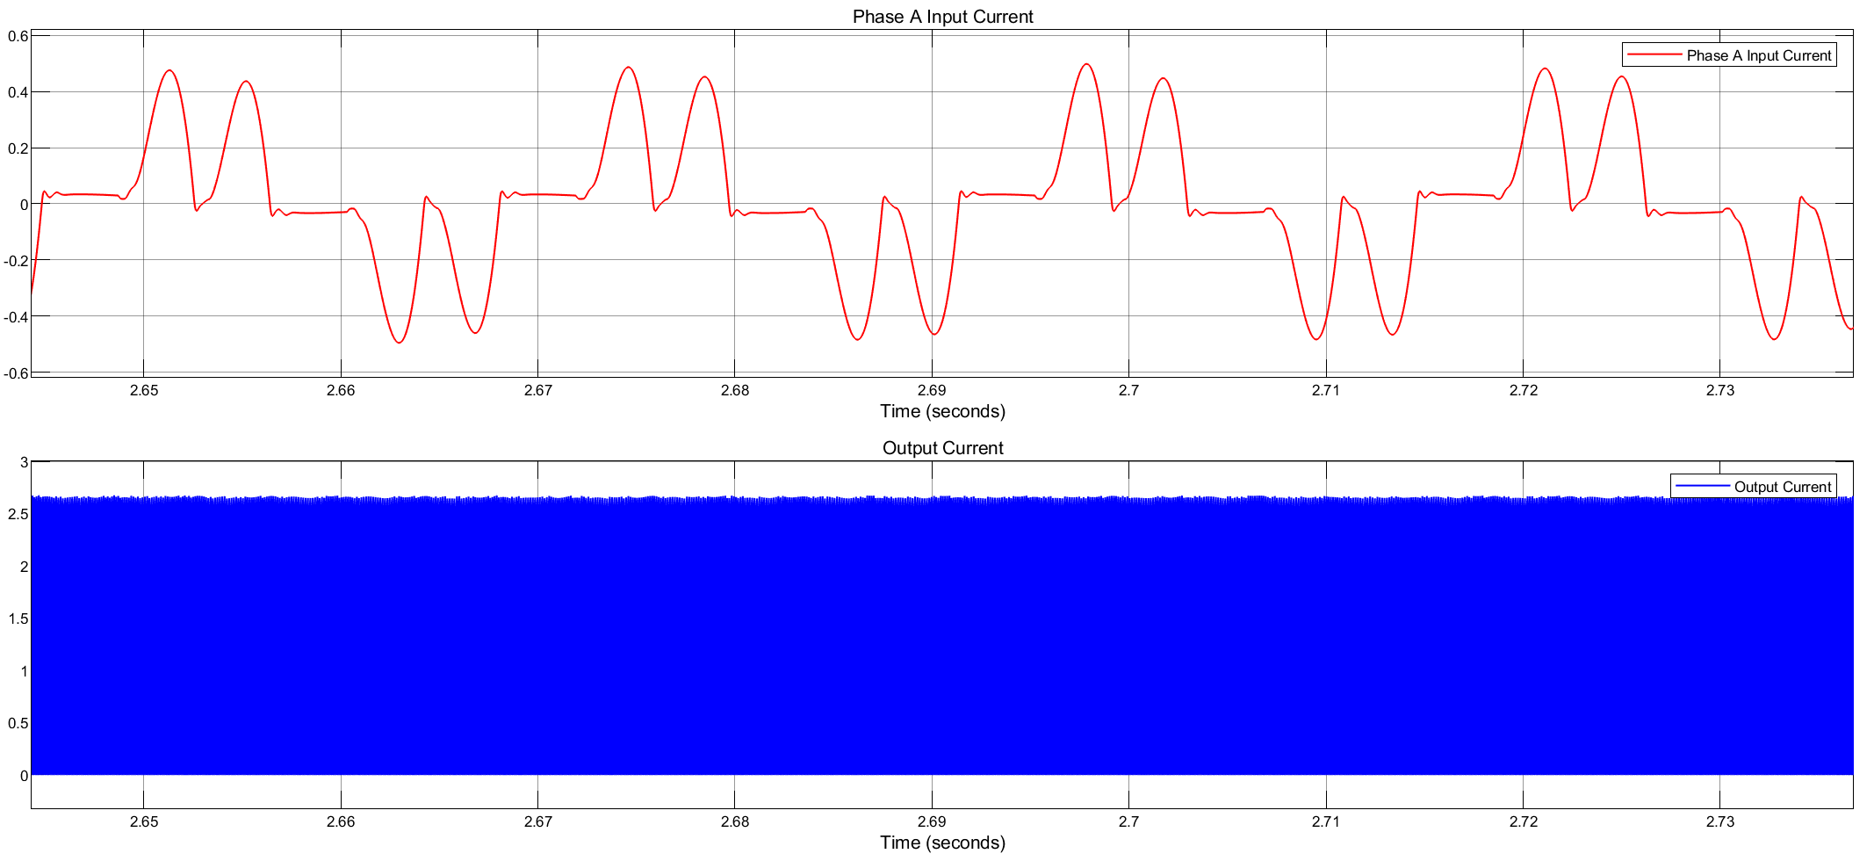

(b)

Figure 4 Rectifier Phase-A Input Current and Output Current

Diodes current and voltage can be observed for 5 seconds interval (a) and a smaller interval (b) to see the boundaries in Figure 5. Below.

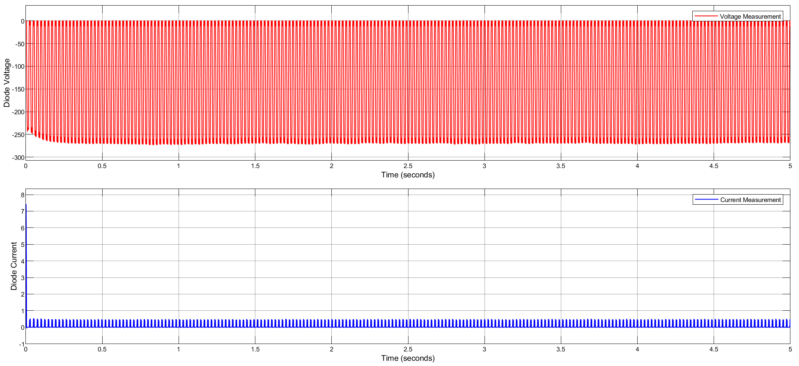

(a)

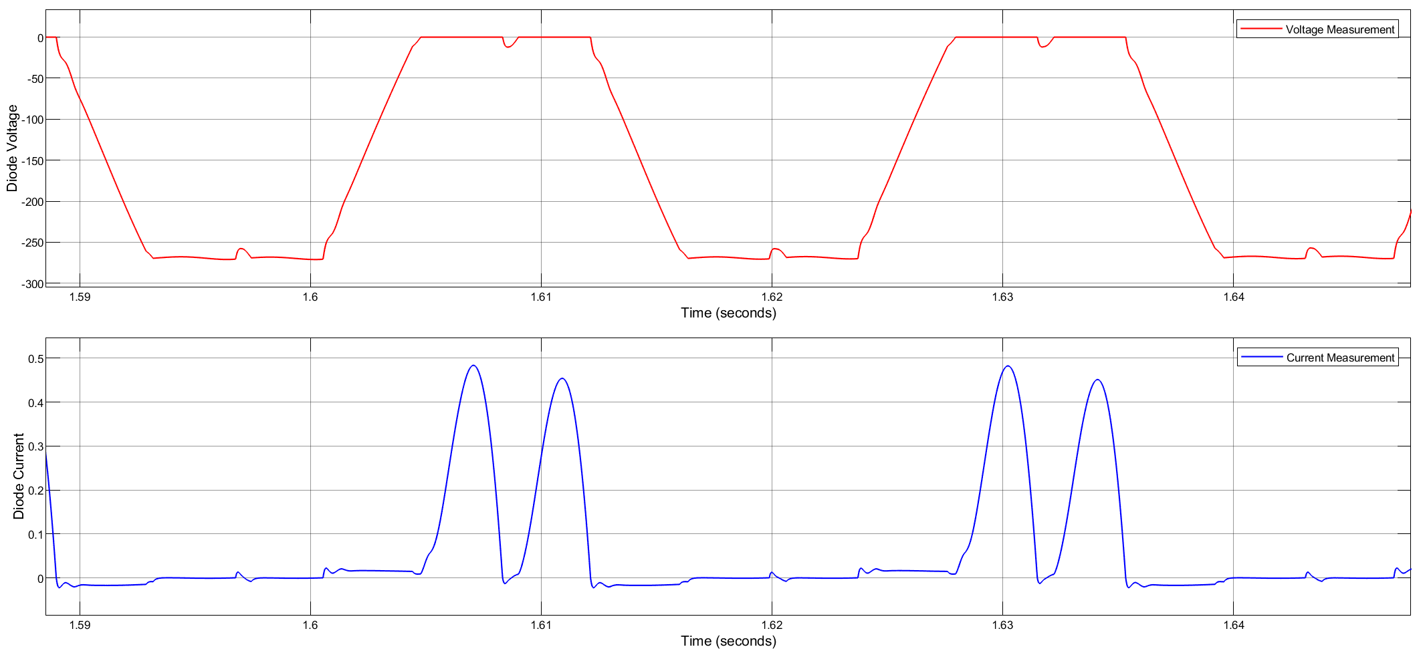

(b)

Figure 5 .Diode Current and Voltage

## Simulations of Buck Converter

The circuit schematic of the buck converter can be seen in Figure 6. In this part of the report, MOSFET current and voltage simulation results, also output current and voltage simulation results can be observed.

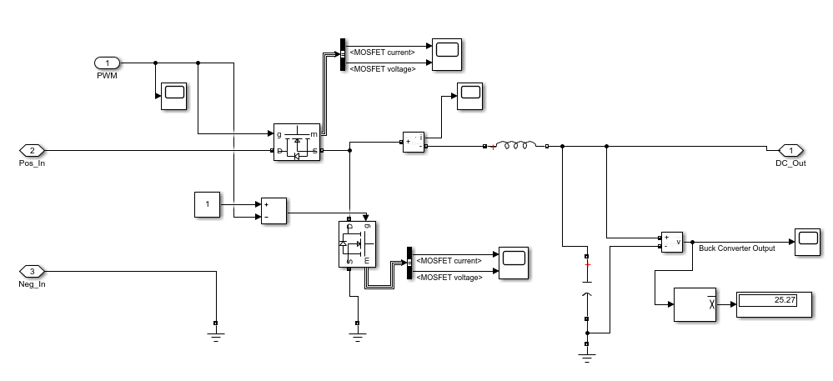

Figure 6. The circuit schematic of buck converter

Since the synchronous buck converter has lower power loss, we decided to use it. On the other hand, it has the disadvantage that it is more complex to control. MOSFET on the top is called the high side which means current flows through to the load. MOSFET on the below is called the low side which means current flows from the supply or load to the ground. We have to drive both of two MOSFETs. High side and low side MOSFETs are driven by PWMs complements of each other because when one diode is on, the other should be off, vice versa. PWM has duty cycle D. In buck converters, the output voltage is found by Equation (1):

[1]

To get 25 V output voltage, duty cycle changes between 0.1 and 0.15 because rectifier output has ripple, not DC. We control the duty cycle by the voltage of a resistor at the battery side. We will discuss this in the controller section.

Also, this topology has an inductor and capacitor as every buck converter has. Firstly, we decided inductance value by Equation (2):

[2]

: desired output voltage (It is desired 25V)

Input voltage (Output voltage of the rectifier)

Switching frequency (It is chosen as 100 kHz)

Estimated inductor ripple current (We estimated it as 0.2A by linearization)

By inserting values into the equation (3), we found inductance value of 1.1 mH. In the simulation, we used 1 mH close to the value found. Also, we used a 100μF capacitor. As seen in Equation (3), as inductance and capacitance increase, the ripple at the output decreases.

[3]

On the other hand, as inductance and capacitance values increase, the size and cost increase, so we wanted an optimum balance between efficiency and them.

In Figure 7. below, buck converter output current and voltage can be observed. It is obvious that the output voltage (battery voltage) is almost 25V DC which is consistent with the requirement of the project. Ripple in current and voltage, especially in voltage is small.

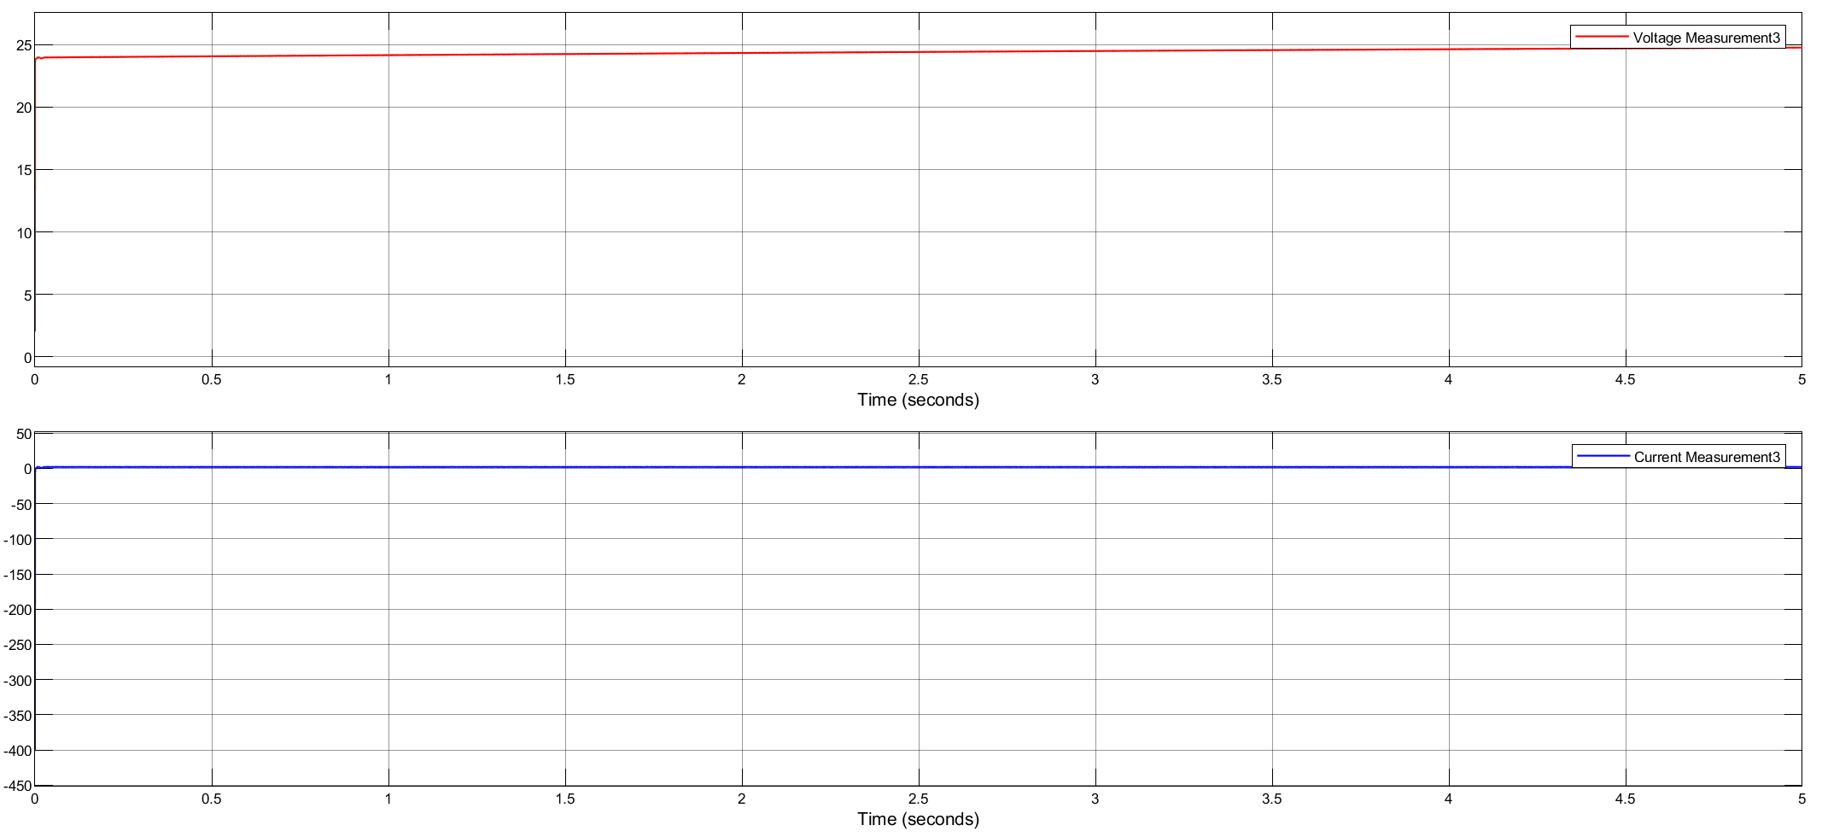

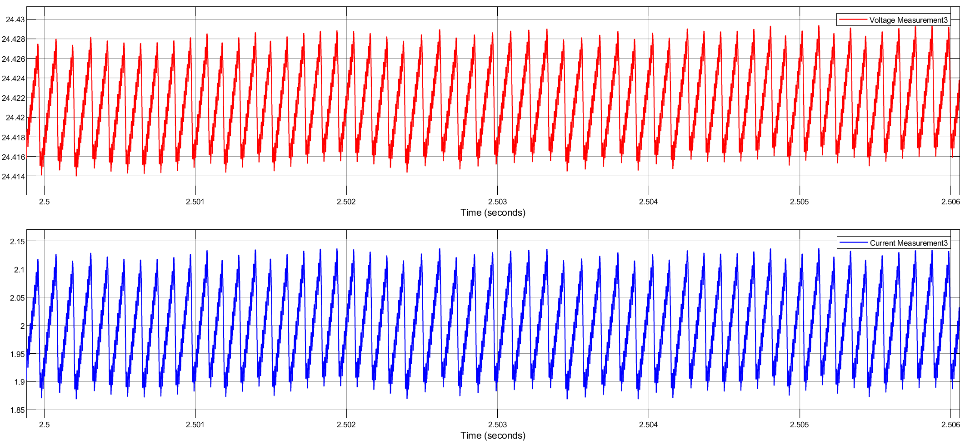

Figure 7 Buck converter output voltage and current

Figure 8. shows MOSFETs voltage and current.

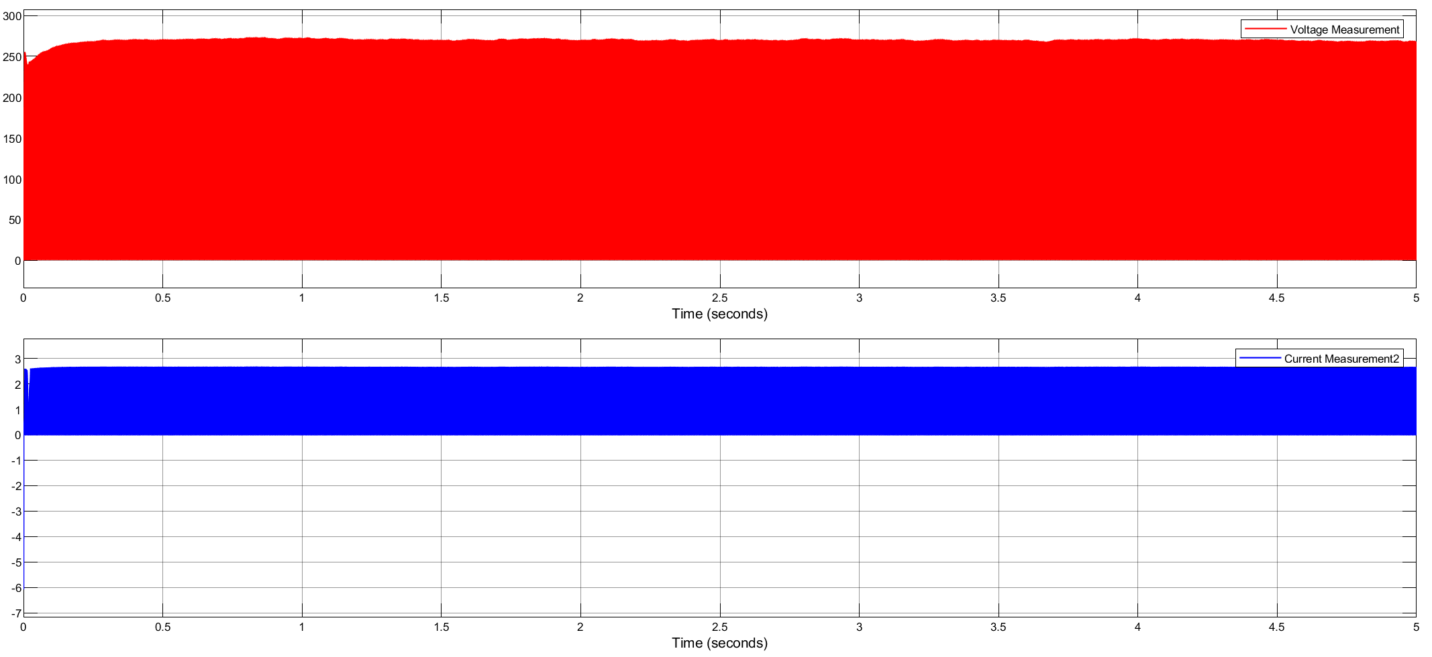

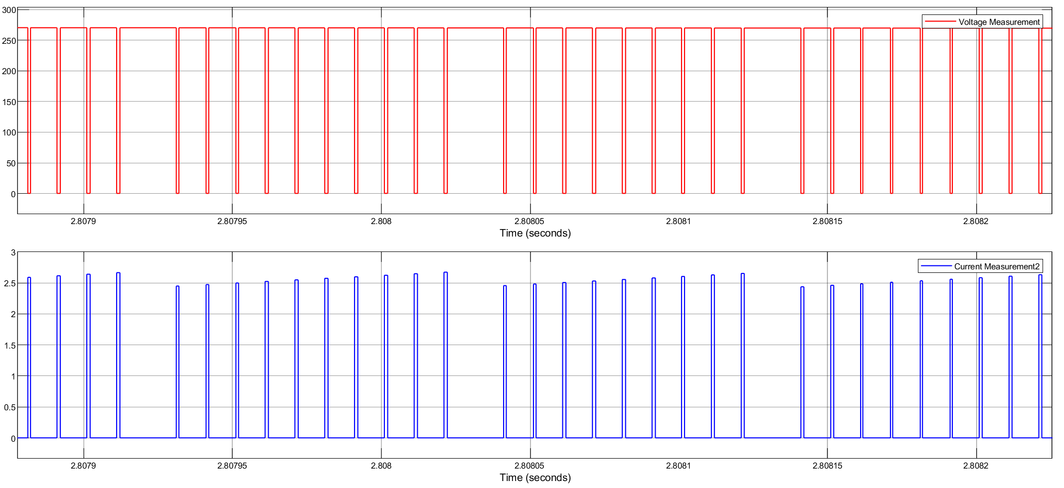

Figure 8. Buck converter MOSFETs voltage and current

## Simulations of Battery Part

The last part of our system is the battery. In this part, 25 V battery voltage and 2 A battery current (ripple is %20 of average current) are desired. We obtained almost 24 V from the previous part (buck converter). To get 2A battery current with the maximum ripple of %20 of the average current, we should use a controller. Our aim is to control the duty cycle of PWM by voltage difference through resistance 0.01 Ohm connected between battery and ground.

Firstly, we tried to implement the P controller. On the other hand, with the P controller we had a huge steady-state error not consistent with battery current requirements, it is expected because steady-state errors are seen in the P controller. For this reason, we focused on other controller types. We tried the hysteresis controller (on-off controller), we obtained less ripple than P controllers do but still it was not consistent with requirements. The on-off controller is not much efficient control way because it does not contain intermediate values. Lastly, we tried the PI controller. Since I term decreases error, we obtained a waveform consistent with the requirement. We arranged P and I values by fine-tuning.

In Figure 9. below, the battery part of our system and the controller we designed can be seen.

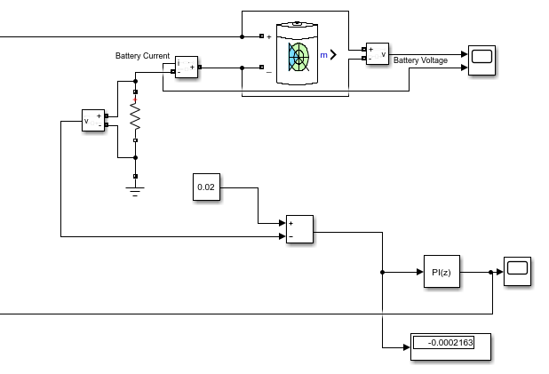

Figure 9. Battery part of our system and PI controller we designed

As seen in Figure 9, we used resistance 0.01 Ohm connected between battery and ground. The desired input current is 2 A, so the desired voltage difference on this resistor is 0.02 V. That is, the set point is 0.02 V. Also, the output is measured voltage difference on the resistor. Error is the difference of them, and our aim is to control it. We arranged P and I values by fine-tuning. The output of the controller is the duty cycle of PWM that drives high side MOSFET. Also, we have mentioned before, complements of this PWM drives low side MOSFET.

In figure 10 below, battery voltage and battery current can be observed.





Figure 10 Battery current and voltage

# Component Selection

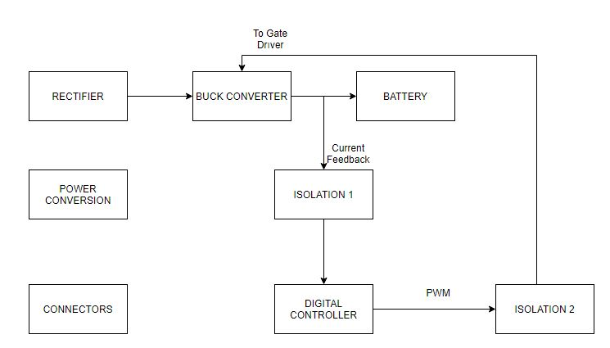

Block diagram 1

In the previous part, we have decided on what components, their values and voltage and current ratings with the Simulink simulation and formulas that we learnt in the lectures. To provide a reliable design, we considered the inrush currents and surge voltages. Therefore, we have chosen our components by considering the maximum power rating and its tolerance.

Also, in our Simulink simulation, we have 3-phase rectifier, Buck Converter, and shunt resistor in order to take feedback, however we are using PI block in order to implement control loop. In real world, we need controllers (analog/digital) to implement this loop, we need gate drivers in order to drive MOSFETs and we need isolations in order to keep logical operations in safe zone.

In this project, we will control our battery current by using a PIC microcontroller. However, these digital controllers are very sensitive and easily disturbed by a noise, so we need to isolate our topology’s analog and digital parts, with a current sensing op-amp. Moreover, we need to take the generated PWM from PIC to our analog circuit side, so we need a digital isolator. Moreover, this coming signal will not be able to drive the MOSFET gates due to low power and voltage, so we need a gate driver with our low-side and high-side MOSFET’s in Buck Converter and this driver must have a bootstrap circuit in order to drive high-side MOSFET. Lastly, we need to feed supplies of these discussed IC’s, so we need to convert battery’s 24V to desired levels, where we will select these desired levels in following sections.

Different than the simulation report, we have made some minor changes in our component selection part, which are some capacitors and inductor to decrease cost and volume. All of the discrete components selected below are validated with simulation results. The prices discussed below are for one quantity selected, the cost calculation will be done for 1000 pieces, by preparing a Bill of Materials list.

## Capacitors

In this project, we will use two electrolytic capacitors, different that IC bypass capacitors; one is in rectifier part in order to stabilize our output DC voltage. For the capacitor value, we have calculated them in the ideal simulation part and simulate them accordingly. In simulation report, we have placed a 1mF capacitor, however, to decrease cost we have chosen our capacitor as 400V, 0.1mF, and in simulation we have seen that we are in safe zone in current control with this capacitor, which is KEMET, ESH107M450AN2AA. By selecting this capacitor, we have saved nearly 6.65 Dollars.

**Link:** https://www.digikey.com/en/products/detail/kemet/ESH107M450AN2AA/7423958?s=N4IgTCBcDaIKIGUASBGADAdgLIBYCsaAggHJiGEgC6AvkA

**Price:** 2.79 Dollars

In Simulation report, we have placed 1mF capacitor, however, to decrease cost and volume, we have simulated our design with a 0.1mF capacitor and seen that our system works properly. So, the new capacitor is Würth, 860020573008, with 35V rating, which decreased the cost nearly 0.20 Dollars.

**Link:** https://www.digikey.com/en/products/detail/w%C3%BCrth-elektronik/860020573008/5728885?s=N4IgTCBcDaIBwDYAMSxIKwHYDMK4gF0BfIA

**Price:** 0.14 Dollars

## Inductor

After simulation report, we have found out that our inductor selection was wrong, due to high price. We firstly wanted to prepare our own inductor, however after some calculations, we find that our designed inductor is very big, so we picked a new inductor which is smaller, and cheaper, and helped us to save nearly 4.10 Dollars.

**Link:** https://www.digikey.com/en/products/detail/abracon-llc/AIRD-02-102K/2660716?s=N4IgTCBcDaIIIEkBKARAtABjGgjFg0iALoC%2BQA

**Price:** 3.38 Dollars

## Diodes

In the design, we will use the diode in two different places. One is for rectifier, there will be six diodes for three-phase. The other one is for gate driver as bootstrap diode.

* For the rectifier, we chose S2G diode for 400V voltage rating, 2A current rating and 10A surge current.

**Link:** https://www.digikey.com/en/products/detail/on-semiconductor/S2G/1049006

**Price:** 0.33 Dollars

* As bootstrap diode, we will use same diode in order to protect gate driver and its supply.

## MOSFET

In simulation report, we have chosen FDD5N50NZTM, for high and low side MOSFET. However, when we make thermal analysis, we have seen that our low side MOSFET’s temperature increases too much, so we have found a new MOSFET.

The new MOSFET that we have found is FDD5N50TM-WS, which has very similar properties with first one, however the thermal resistance and drain source resistance is low compared with first one. So, we have decided to use that MOSFET for both high and low sides.

**Link:** https://www.digikey.com/en/products/detail/on-semiconductor/FDD5N50TM-WS/1954279

**Price:** 0.94 Dollars

## Shunt Resistor

In order to take the feedback from the battery, we should use a shunt resistor. This resistor should be low power component in order to reduce the power loss. Therefore, we chose 10m Ω, and 0402 package in order to keep our design compactness, CSS0402FT10L0.

**Link:** https://www.digikey.com/en/products/detail/stackpole-electronics-inc/CSS0402FT10L0/10719366

**Price:** 0.56 Dollars

## Isolation Op-Amp

Like in every component, we need a cheap and feasible isolation op-amp in order to isolate our Shunt Voltage from the logic side of the circuit. For this purpose, a two channel op-amp was enough for us, and while doing our research, we have found SI8920BC (Silicon Labs) model current sensing isolation op-amp. This model is one of the cheapest isolation op-amps in Digikey and has specifications that we are needed at all. SI8920 has a supply range 3.0V to 5.5V, its differential inputs are capable up to +/-200mV, it is default gain is 8.1 and in datasheet, its typical usage is for current sensing, which is our purpose.

We want all of the IC’s with 3.3V supply in our circuit, where SI8920BC is suitable, our shunt voltage will be around 20mV (with 0.01 ohm shunt resistor and the current is around 2A), and with gain, it’s output will be around 160mV, where this voltage is enough for ADC readings. As a consequence of the features that we count above, we have chosen the SI8920BC for our shunt voltage isolation.

**Link:** https://www.digikey.com/en/products/detail/silicon-labs/SI8920BC-IP/5358956

**Price:** 2.93 Dollars

## Digital Isolator

In our Buck Converter, we have two MOSFETs which are standing for high side and for low side. In order to use these MOSFETs as switches, we need PWMs, which are generated from the controller which will be discussed below. As we mentioned, our controller side will be isolated, so we need a digital isolator which will carry logic side generated PWMs into our analog side.

We will have two PWMs, and for them a two channel digital isolator will be enough for us. As we mentioned before, we are planning the supplies of ICs as 3.3V, so we need to select our digital isolator in that way. When we filtered the components with desired properties above, we have found SI8620AB (Silicon Labs). This digital isolator is a unidirectional, two-channel, 2.5V-5.5V supply range and one of the cheapest solutions. As a consequence of discussed properties, we are selected SI8620AB for our digital isolator.

**Link:** https://www.digikey.com/en/products/detail/silicon-labs/SI8620AB-B-IS/4576730

**Price:** 1.11 Dollars

## Digital Controller

In our topology, we are selected to control our battery current with a digital controller in order to have an adjustable, reliable, and easy setup circuit. By using a digital controller, we are getting away from complicated and fixed burden of analog controllers. If we use an analog controller, we cannot change control parameters P and I easily when there is an application error of control loop. Moreover, with digital controller, our circuit will be able to charge battery for different currents, which will make our design more desirable.

For digital controller, we wanted to use Microchip’s PIC controllers, due to their easy and useful configuration. When we looked into PIC and dsPIC microcontrollers, we have seen that dsPICs are more complicated, however we only need a Analog-to-Digital Converter and PWM generator, so we decided to move into PIC controllers. When we make a research on Microchip website for ADC and PWM modules with cheap solutions, we are ended up on PIC16F16 series controllers, because these series are specialized for PID control and math operations. While looking the cheapest solution, we have found PIC16F1613 module, which is a fourteen-pin small controller, however there is not a separated PWM module in this PIC16F1613, PWM module is connected to Compare-Capture Module, which may be problematic while initializing PWM in code, so we moved into PIC16F1614. This module has 10-bit ADC module configurable for all analog pins and a CWG (complementary waveform generator) module which is suitable for driving of a half-bridge, again this module is configurable for all digital pins.

To conclude, with 3.3V supply, 10-bit ADC, CWG, specialized for PID control and cheap price features, we are decided to use PIC16F1614 as digital controller in our circuit.

**Link:** https://www.digikey.com/en/products/detail/microchip-technology/PIC16F1614-E-SL/5050777

**Price:** 1.06 Dollars

## Gate Driver

In our Buck Converter, we have two MOSFETs for high side and low side which will be driven complementary, with PWMs generated from our digital controller, however these PWMs are not have enough voltage to drive our MOSFET gates, moreover for high side we need a bootstrap configuration for drive. For this purpose, we need a gate driver in our circuit.

From our simulations, we know that our high side MOSFET sees a voltage up to 300V between drain and source, so we need to select a suitable driver. Moreover, in order to prevent short circuit between drain of high side and source of low side we need a proper dead time between complementary PWMs, by considering turn-on and off delay times. When we look the datasheet of our MOSFETs in Buck Converter (FDD5N50NZ), the maximum turn-on delay time is 35ns and the maximum turn-off delay time is 65ns, so at least we need a dead time higher than 100ns.

While doing our research on Digikey, we have ended up with 2 models, which are 2ED2182S06FXUMA1 and BS2103F, with 650V and 600V high voltage purpose, respectively. Both models are suitable for our voltage range and have bootstrap application, however the first model is expensive than second. When we look further, we see that gate current of first one is up to 2.5A and the second one is 130mA. We are using MOSFETs, so we do not need a high gate current, when we examine the datasheet of the first one, we see that it is suitable for IGBT, too, due to high gate current. When we look dead times, first one has 400ns dead time and it is adjustable with R-C circuit, and second one has fixed 160ns dead time.

As we discussed above, a dead time higher than 100ns is suitable for us, and we are driving MOSFETs, we do not need high gate current, for this purpose we have selected 2nd option, which is cheaper, BS2103F. This model has supply range between 10V and 18V.

**Link:** https://www.digikey.com/en/products/detail/rohm-semiconductor/BS2103F-E2/5955649?s=N4IgTCBcDaIAQCEDKYCMAGAzAMQLQFEIBdAXyA

**Price:** 0.99 Dollars

## Power Conversion Units

As we mentioned above, except gate driver, we have selected all of our IC’s with 3.3V, and our gate driver has a supply range between 10V and 18V. We can select supply of gate driver as 12V, so we need to convert 24V battery voltage into 12V and 3.3V separately, and for isolated supplies, we need to convert 3.3V into isolated 3.3V, which means we need three converters which are 24V/12V, 24V/3.3V, 3.3V/Isolated 3.3V.

In following sections, we have decided our conversions with cheapest way with considering IC supply currents.

### 24V/12V Conversion:

When we look cheapest solution for 24V/12V conversion, we have ended up with UA7812CKCS, which is a linear voltage regulator with fixed 3.3V 1.5A output for 14.5V-25V input range. This will supply only gate driver, whose supply current is at most 1mA, where our converter is enough. Moreover, in this model is through hole, so we can place it vertically in our circuit for lower space.

**Link:** https://www.digikey.com/en/products/detail/texas-instruments/UA7812CKCS/521614

**Price:** 0.79 Dollars

### 24V/3.3V Conversion

While doing our research for 24V/3.3V conversion, we have ended up in two models which are BA033CC0FP and UA78M33CKVURG3, which are LDO and Linear regulators, respectively. A LDO regulator is more power efficient, moreover our LDO regulator is 1A, however our linear regulator is cheaper but has 500mA output. When we look our ICs, we have 2 ICs with 3.3V supply and in the worst case, isolated op-amp draws 4.2mA maximum, for digital isolation that current is 1.2mA. Which means we do not need high currents, so we have selected the second one which is UA78M33CKVURG3, cheaper solution.

**Link:** https://www.digikey.com/en/products/detail/texas-instruments/UA78M33CKVURG3/1216814?s=N4IgTCBcDaIAQFUCCB2AHAWQMxYMIGkA1BAJQHEsQBdAXyA

**Price:** 0.58 Dollars

### 3.3V Isolation

For a non-disturbed operation, we need that isolation, however the isolation is a very expensive event. Due to this fact, we have selected the cheapest solution for 3.3V isolation. While we are doing our research, we have found R1SX-3333R, which gives isolated 3.3V with 303mA output. We have three IC’s with isolated 3.3V supply, and the worst one in worst case draws 4.2mA according to datasheet, so 303mA is enough.

**Link:** https://www.digikey.com/en/products/detail/recom-power/R1SX-3-33-3-R/6708872?s=N4IgTCBcDaIEoEYDKANAtAZgHQextcIAugL5A

**Price:** 2.94 Dollars

## Connectors

We have three terminals in our circuit which are motor phases, battery terminals and in circuit serial programming (ICSP) pins. For motor phases and battery terminals we will use screw connectors, and for ICSP we will use headers.

* **Motor Connector Link:** https://www.digikey.com/en/products/detail/phoenix-contact/5452258/4391131?s=N4IgTCBcDaIKwBY5jHAHCAugXyA
* **Battery Connector Link:** https://www.digikey.com/en/products/detail/cui-devices/TB007-508-02BE/10064127?s=N4IgTCBcDaICoCEAMSDsBaArEgHOpYCAoiALoC%2BQA
* **ICSP Connector Link:** https://www.digikey.com/en/products/detail/adam-tech/PH2-06-UA/9830396

**Total Price:** 2.44 Dollars

## Heatsink

In the buck converter part of the circuit, we used two heatsinks with different thermal resistances for the low side and high side MOSFETs. After completing the thermal analysis, we noticed that we must use heatsinks for MOSFETs. Then, we calculated the required thermal resistance to achieve maximum junction temperatures (150°C). When we select the heatsinks, we paid attention to the volumes of heatsinks and of course their thermal resistances.

* For the high side MOSFET, we have decided to use V-1100-SMD/B-L heatsink that has 25 °C/W thermal resistance:

**Link:** https://www.digikey.com/en/products/detail/assmann-wsw-components/V-1100-SMD-B-L/3511509

* For the low side MOSFET, we have decided to use 573100D00000G heatsink that has 15 °C/W thermal resistance:

**Link:** https://www.digikey.com/en/products/detail/aavid-thermal-division-of-boyd-corporation/573100D00000G/1625595

# Cost Analysis

After deciding the component one by one, we added them to cart on the Digikey to see how much money cost to produce 1000 circuitry. We included the consumable parts such as required resistors and capacitors by the IC’s. Then, we ordered the PCB from PCBway website. We input the PCB specifications such as dimensions, number of layers, quantity etc. we obtained a price for 1000 PCBs. The PCB specifications Figure 11.



Figure 11 PCB Specification Selection

The total price for 1000 circuity is 17085.65 $. That means the price is 17.09 $ per circuitry. PCB price and the BOM list can be seen in Figure 12 and Table 1.

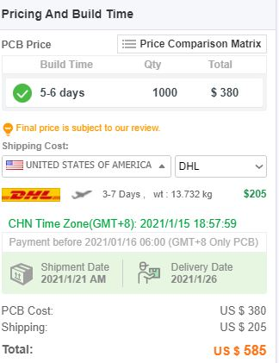

Figure 12 PCB price

Table 1 BOM List

|  |  |  |  |  |  |  |  |  |
| --- | --- | --- | --- | --- | --- | --- | --- | --- |
| **Index** | **Quantity** | **Part Number** | **Manufacturer Part Number** | **Description** | **Available** | **Backorder** | **Unit Price** | **Extended Price [$]** |
| 1 | 1000 | 399-15674-ND | ESH107M450AN2AA | CAP ALUM 100UF 20% 450V T/H | 1000 | 0 | 1,15072 | 1.150,72 |
| 2 | 1000 | 732-8942-1-ND | 860020573008 | CAP ALUM 100UF 20% 35V RADIAL | 1000 | 0 | 0,08 | 80,00 |
| 3 | 2000 | FDD5N50TM/WS | FDD5N50TM/WS | MOSFET N-CH 500 4A DPAK | 1637 | 363 | 0,396 | 792,00 |
| 4 | 1000 | 535-11423-ND | AIRD-02-102K | FIXED IND 1MH 1A 818 MOHM TH | 414 | 586 | 1,8432 | 1.843,20 |
| 5 | 1000 | BS2103F-E2CT-ND | BS2103F-E2 | IC GATE DRVR HALF-BRIDGE 8SOP | 74 | 926 | 0,42 | 420,00 |
| 6 | 2000 | AE10774TR-ND | V-1100-SMD/B | HEAT SINK COPPER DPAK TO-252 | 0 | 2000 | 0,4437 | 887,40 |
| 7 | 1000 | 336-3329-5-ND | SI8920BC-IP | IC ISOLATION 8DIP GULL WING | 872 | 128 | 2,65551 | 2.655,51 |
| 8 | 6000 | S2GFSTR-ND | S2G | DIODE GEN PURP 400V 2A DO214AA | 0 | 6000 | 0,05698 | 341,88 |
| 9 | 1000 | S2GFSCT-ND | S2G | DIODE GEN PURP 400V 2A DO214AA | 811 | 189 | 0,07084 | 70,84 |
| 10 | 1000 | SI8620AB-B-IS-ND | SI8620AB-B-IS | DGTL ISO 2500VRMS 2CH GP 8SOIC | 223 | 777 | 1,01701 | 1.017,01 |
| 11 | 1000 | PIC16F1614-E/SL-ND | PIC16F1614-E/SL | IC MCU 8BIT 7KB FLASH 14SOIC | 864 | 136 | 0,88 | 880,00 |
| 12 | 1000 | 738-CSS0402FT10L0CT-ND | CSS0402FT10L0 | RES SHUNT, 0402, 0.01 OHM, 1%, 0 | 1000 | 0 | 0,112 | 112,00 |
| 13 | 1000 | 296-21208-1-ND | UA78M33CKVURG3 | IC REG LINEAR 3.3V 500MA TO252-3 | 1000 | 0 | 0,22475 | 224,75 |
| 14 | 1000 | 296-13998-5-ND | UA7812CKCS | IC REG LINEAR 12V 1.5A TO220-3 | 1000 | 0 | 0,3045 | 304,50 |
| 15 | 900 | 945-3053-2-ND | R1SX-3.33.3-R | DC-DC CONVERTER 3.3V 1W | 900 | 0 | 2,352 | 2.116,80 |
| **Index** | **Quantity** | **Part Number** | **Manufacturer Part Number** | **Description** | **Available** | **Backorder** | **Unit Price** | **Extended Price [$]** |
| 16 | 100 | 945-3053-1-ND | R1SX-3.33.3-R | DC-DC CONVERTER 3.3V 1W | 100 | 0 | 2,604 | 260,40 |
| 17 | 1000 | 277-15492-ND | 5452258 | TERM BLK 3P SIDE ENT 5.08MM PCB | 168 | 832 | 1,11781 | 1.117,81 |
| 18 | 1000 | 102-6203-ND | TB007-508-02BE | TERMINAL BLOCK, SCREW TYPE, 5.08 | 1000 | 0 | 0,1872 | 187,20 |
| 19 | 1000 | 2057-PH2-06-UA-ND | PH2-06-UA | CONN HEADER VERT 6POS 2.54MM | 1000 | 0 | 0,04836 | 48,36 |
| 20 | 2000 | 399-C0603C103M5RAC7411CT-ND | C0603C103M5RAC7411 | CAP CER 10000PF 50V X7R 0603 | 2000 | 0 | 0,00756 | 15,12 |
| 21 | 8000 | 2571-GMC10X7R104K50NTTR-ND | GMC10X7R104K50NT | CAP CER 0.1UF 50V X7R 0603 | 8000 | 0 | 0,0042 | 33,60 |
| 22 | 4000 | 2571-GMC10X7R105K25NTTR-ND | GMC10X7R105K25NT | CAP CER 1UF 25V X7R 0603 | 4000 | 0 | 0,0082 | 32,80 |
| 23 | 2000 | 732-7992-1-ND | 885012206074 | CAP CER 0.33UF 25V X7R 0603 | 2000 | 0 | 0,06376 | 127,52 |
| 24 | 1000 | 1276-7076-1-ND | CL10A226MO7JZNC | CAP CER 22UF 16V X5R 0603 | 1000 | 0 | 0,18902 | 189,02 |
| 25 | 4000 | 2019-RK73B1JTTD200GCT-ND | RK73B1JTTD200G | RES 20 OHM 2% 1/8W 0603 | 0 | 4000 | 0,01068 | 42,72 |
| 26 | 1000 | 2019-RK73B1JRTTD472GCT-ND | RK73B1JRTTD472G | RES 4.7 KOHM 2% 1/10W 0603 | 0 | 1000 | 0,01703 | 17,03 |
| 27 | 2000 | 2019-RK73B1JRTTD102GCT-ND | RK73B1JRTTD102G | RES 1 KOHM 2% 1/8W 0603 | 0 | 2000 | 0,01703 | 34,06 |
| 28 | 3000 | 2019-RK73B1JTTD103GCT-ND | RK73B1JTTD103G | RES 10K OHM 2% 1/10W 0603 | 0 | 3000 | 0,01068 | 32,04 |
| 29 | 2000 | 2019-RK73B1JTTD562GCT-ND | RK73B1JTTD562G | RES 5.6K OHM 2% 1/10W 0603 | 0 | 2000 | 0,01068 | 21,36 |
| 30 | 1000 | PCB | | | | | 5,85 | 585 |
| **TOTAL** | | | | | | | | **17085.65 $** |

# Power Losses

In this part of the report, firstly we will state losses on the diodes and MOSFETs, then we will calculate them.

## Diode Losses

In diodes there are two main losses. They are conduction and reverse recovery losses.

### Conduction Losses

Conduction losses are simply product of forward voltage of diode and average current flowing through it. It is found by Equation 4:

[4]

Conduction losses are observed when diode is conducting current. Our diode has forward voltage of 1.1 V. Also, we observed that average current passing through it 0.5 A. Thus, we find conduction loss:

### Reverse Recovery Losses

When diode is in reverse biased mode, carriers are moved out from the layer until the current in the forward direction becomes zero. At that time, reverse current flows through the diode. It is also called recovery current. This current causes reverse recovery losses. It is found by Equation 5:

[5]

Where,

Reverse voltage (V)

Switching frequency (Hz)

Reverse recovery charge (C)

Reverse recovery time (sec)

Reverse recovery current (A)

We observed that reverse voltage on the diodes are around 260 V from the simulation results. We took switching frequency as 100 kHz in the simulation. Diode we chose has reverse recovery charge that can be seen from the datasheet. Thus, reverse recovery loss is calculated:

As a result, losses on a diode:

Since we have six diodes in the design, total losses on the diodes:

## MOSFET Losses

In MOSFETs there are two main losses. They are conduction and switching losses.

### Conduction Losses

Conduction losses of MOSFETs are simply product of drain to source on resistance of MOSFET and average current flowing through it. Since we used synchronous buck converter in our design, conduction losses of low side and high side MOSFETs are calculated separately. Conduction loss of low side and high side MOSFETs are calculated by Equation 6 and 7:

[6]

[7]

Where,

Conduction loss of low side MOSFET (W)

Conduction loss of high side MOSFET (W)

Drain to source on resistance of MOSFET (Ω)

Average current passing through MOSFET (A)

Duty cycle

We observed from the datasheet that our MOSFETs have 1.15 Ω drain to source on resistance Also average current passing through it and average duty cycle of our design are 2.5 A and 20%, respectively. Thus, conduction loss of low side and high side MOSFETs are calculated:

### Switching Losses

As MOSFET switches turn on and off, energy is dissipated due to parasitic effects (rise and fall time). This type of loss is called switching losses. Switching losses of high side and low side MOSFETs are calculated by Equation 8 and 9:

[8]

[9]

Where

Input voltage (V)

Forward voltage of low side MOSFET body diode (V)

Average current passing through MOSFET (A)

Turn on rise time (sec)

Turn off fall time (sec)

Switching frequency (Hz)

For high side MOSFET, in our design, is around 120 V. Also, as we mentioned before, average current passing through MOSFET is 2.5 A. Also, and values of the MOSFET are 22ns and 20ns, respectively. As a result, switching loss of high side MOSFET is calculated:

For low side MOSFET, in our design, is around 0.9 V. We observed this value from the reverse current vs body diode voltage graph in its datasheet. Also, as we mentioned before, average current passing through MOSFET is 2.5 A. Also, and values of the MOSFET are 22ns and 20ns, respectively. As a result, switching loss of low side MOSFET is calculated:

Total power loss of low side MOSFET:

Total power loss of high side MOSFET:

## IC Losses

Although the IC’s are designed to be required very power consumption principle, they still cause losses on the circuitries. Therefore, we have calculated the power losses caused by IC components. Since they consume power proportional to their input voltage and input current, we can tabulate the losses as seen on Table 2.

Table 2 IC losses

|  |  |  |  |
| --- | --- | --- | --- |
| **Component Name** | **Input Voltage [V]** | **Input Current [mA]** | **Power Loss [mW]** |
| Gate Driver | 3.3 | 0.040 | 0.132 |
| PIC | 3.3 | 0.032 | 0.106 |
| 24/3.3V Converter | 24 | 4.5 | 108 |
| 24/12V Converter | 24 | 4.2 | 100.8 |
| 3.3V Isolator | 3.3 | 40 | 132 |
| Digital Isolator | 3.3 | 1.5 | 4.95 |
| Isolated Op-amp | 3.3 | 4.2 | 13.86 |

As seen on the Table 1, the total loss is only around 360 mW, which is a very low value by considering the MOSFET and diode losses.

# Thermal Analysis

In this part of the report, thermal analysis for diodes and MOSFET will be done. Firstly, we will analyze without heatsink. Then, if temperature exceeds the range for diodes and MOSFETs, we will state heatsink requirements. Finally, we will analyze (if required) the temperature with selected heatsinks.

## Diode Thermal Analysis

We calculated losses of one diode First, thermal analysis for a diode without heatsink is calculated by Equation 10:

[10]

Where

Junction temperature of the diode

Ambient temperature (25°C)

Power loss of the diode

Thermal resistance, junction to ambient (°C/W)

We observed from datasheet of the diode that the diode has junction to ambient thermal resistance of 53 °C/W. Junction temperature of the diode is calculated:

The diode can operate between temperatures of -65°C and +150°C. 124.375°C is consistent with this temperature range. As a result, heatsink is not needed for the diodes.

## MOSFETs Thermal Analysis

In this part, we will analyze the temperature of high side and low side MOSFETs separately.

### High Side MOSFET

From power losses part, we calculated power losses of high side MOSFET as 2.0675 W. First, thermal analysis for high side MOSFET without heatsink is calculated:

In this calculation, we took ambient temperature as 25°C. Also, the MOSFET has junction to ambient thermal resistance of 110°C/W. The MOSFET can operate between temperatures of -55°C and +150°C. We calculated junction temperature 252.42°C without heatsink. This value is out of operating junction temperature range, so we must use heatsink for high side MOSFET.

Required thermal resistance to achieve maximum 150°C junction temperature at 25°C ambient is calculated by Equation 11:

[11]

Thermal resistance, junction to case (°C/W)

Thermal resistance of heatsink (°C/W)

The MOSFET has junction to case thermal resistance of 1.4°C/W. Required maximum heatsink thermal resistance is found:

That is, heatsink we will select must satisfy .

We have decided to use V-1100-SMD/B-L heatsink because it is not expensive and has small volume with respect to others. It has 25 °C/W thermal resistance consistent with the requirements. As a result, junction temperature with heatsink is found:

### Low Side MOSFET

From power losses part, we calculated power losses of low side MOSFET as 5.7547 W. First, thermal analysis for high side MOSFET without heatsink is calculated:

In this calculation, we took ambient temperature as 25°C. Also, the MOSFET has junction to ambient thermal resistance of 110°C/W. The MOSFET can operate between temperatures of -55°C and +150°C. We calculated junction temperature 658.017°C without heatsink. This value is out of operating junction temperature range, so we must use heatsink for low side MOSFET.

Required thermal resistance to achieve maximum 150°C junction temperature at 25°C ambient is calculated by Equation:

[12]

Thermal resistance, junction to case (°C/W)

Thermal resistance of heatsink (°C/W)

The MOSFET has junction to case thermal resistance of 1.4°C/W. Required maximum heatsink thermal resistance is found:

That is, heatsink we will select must satisfy .

We have decided to use 573100D00000G heatsink. It is more expensive than heatsink for high side MOSFET. On the other hand, it has small volume with respect to others. Heatsinks for high side and low side MOSFETs are almost same volume. It has 15 °C/W thermal resistance consistent with the requirements. As a result, junction temperature with heatsink is found:

# Schematic Design

After concluding our topology selection, ideal/non-ideal simulation results and component selection part, we moved into schematic design part. In schematic part we have used Altium Designer 20, we have worked hierarchically which have eased our design. Our subparts are rectifier unit, converter unit, isolation unit, logic unit, power unit and connector unit. Overview of hierarchy can be seen in Figure 13.

Different than simulation report, we have corrected some inductor and capacitor values as we discussed in Component Selection part, in order to decrease cost and volume of our board.

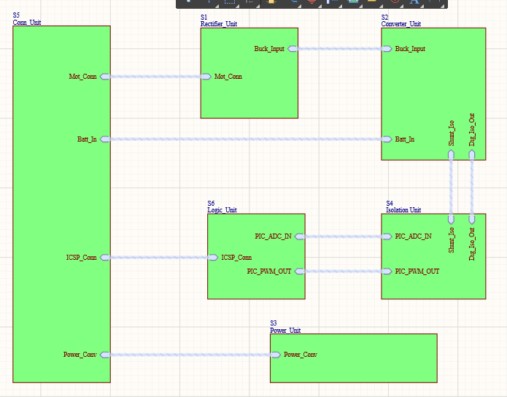

Figure 13. Overview of Hierarchical Design

## Rectifier Unit

As seen in Figure 14, in our rectifier unit we have our selected diodes and capacitor for three phase diode rectifiers, which has the same design with Simulink simulations. Different than simulation report, we have corrected output capacitor.

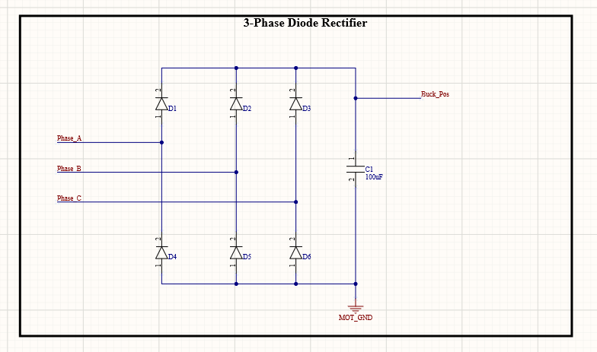

Figure 14. Three Phase Full Bridge Diode Rectifier Schematic

## Converter Unit

In converter unit, we have three parts which are buck converter, shunt resistor and gate driver. Buck converter design is same with Simulink simulations, shunt resistor is connected between negative terminal of battery and ground, which can be seen in Figure 15. Different than our simulation report, we have corrected output capacitor and inductor values.

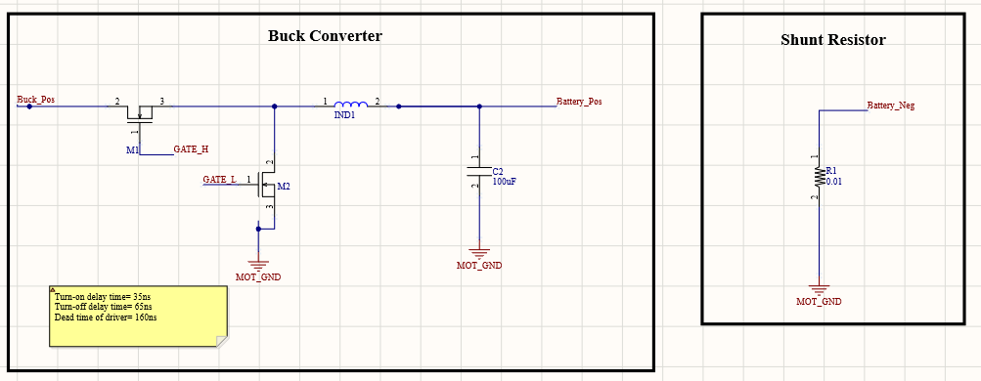

Figure 15. Buck Converter and Shunt Resistor Schematic

When we examined the selected gate driver’s datasheet, in recommended connection we are needed a 1uF bootstrap capacitor, and two times of bootstrap capacitor for supply bypass capacitance. Moreover, for bootstrap circuit, we need a diode between supply and positive terminal of bootstrap capacitor. While driving MOSFET gates, small resistances are required for current slew rate, so we added 20 ohms to gate paths. These discussed features of gate driver circuit can be examined in Figure 16. Different than our simulation report, we have included gate pull-down resistors for safe operation, to prevent our IC and MOSFETs.

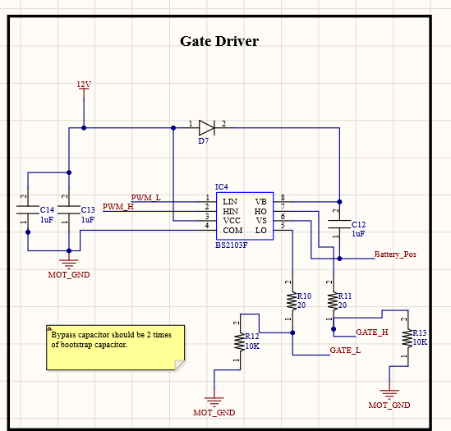

Figure 16. Gate Driver Schematic

## Isolation Unit

As we discussed in component selection part, we are needed isolation for digital side of our circuit. In our schematic, isolation unit includes two main parts which are isolating op-amp and digital isolator.

When we examine the datasheet of our selected isolating op-amp, we see that for both supplies we are needed 100nF bypass capacitors, for differential input of our op-amp we are given a recommended filtering R-C circuit constructed with 20 ohm resistors and 10nF capacitor. At the output of isolation, we need again filtering for ADC input, and the cut-off frequency is determined by user. The only information given is resistors should be bigger than 5kohms. We have set our PWM frequency as 100kHz and cut-off frequency as 15kHz to prevent isolation from PWM noise, we have assumed the resistors as 5.6kohms, so we have found the filtering capacitor as 1uF. Isolation op-amp circuit can be examined in Figure 17.

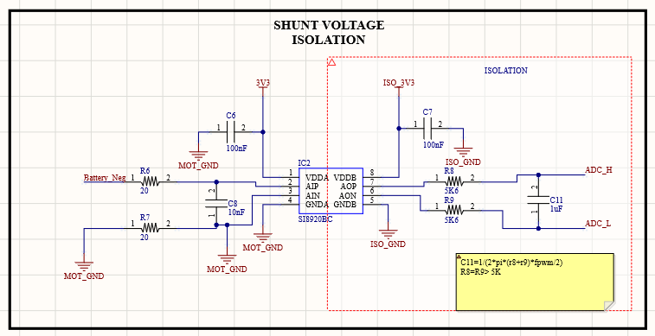

Figure 17. Isolating Op-amp Schematic

In our selected digital isolator, we only need bypass capacitors which are recommended in datasheet as 100nF. In Figure 18, digital isolator schematic can be seen.

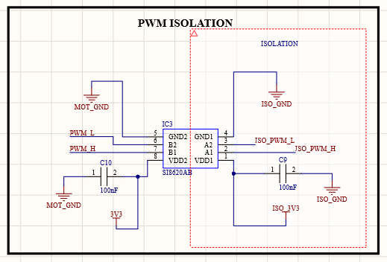

Figure 18. Digital Isolation Schematic

## Logic Unit

In logic unit, we have our selected digital controller which is PIC16F1614. In the datasheet of this controller, we need bypass capacitors 10nF and 100nF. In this microcontroller, we have pins for in circuit serial programming which are MCLR, ICSPDAT and ICSPCLK, which are connecting to PICKIT. In recommended connection, ICSPDAT and ICSPCLK have direct connection, however we are given a recommended connection for MCLR with 10kohms and 4.7kohms resistor and 100nF bypass capacitor. Moreover, in this part of schematic we have ADC inputs and PWM outputs, where PWM outputs have pull-down resistors for safe operation. Schematic of controller can be seen in Figure 19.

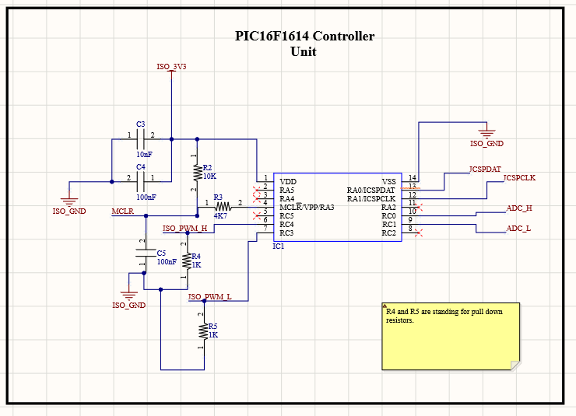

Figure 19. Controller Schematic

## Power Unit

In power unit of schematic, we have selected 24V/12V, 24V/3.3V and 3.3V Isolation equipment. In this part, we only have extra bypass capacitors that are recommended in datasheets. In Figure 20 24V/12V and 24V/3.3V, and in Figure 21 3V isolation schematics can be seen.

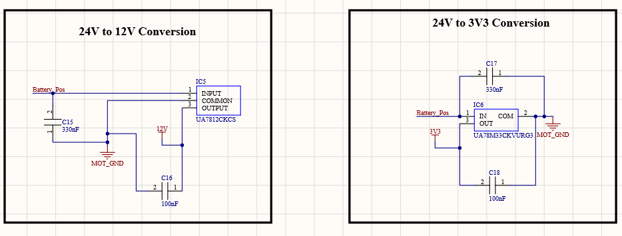

Figure 20. 24V/12V and 24V/3.3V Conversion Schematic

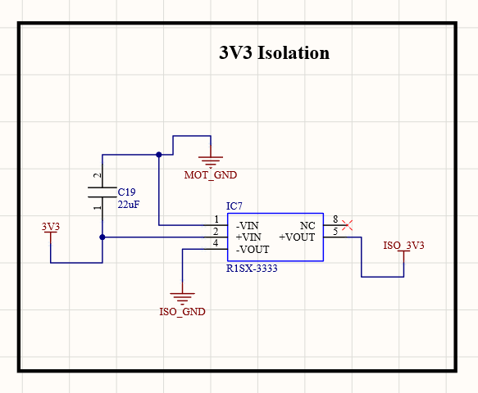

Figure 21. 3.3V Isolation Schematic

## Connector Unit

As we discussed before, we will use screw connectors and headers in order to achieve flexibility in connections. Schematic of connectors can be seen in figure 22.

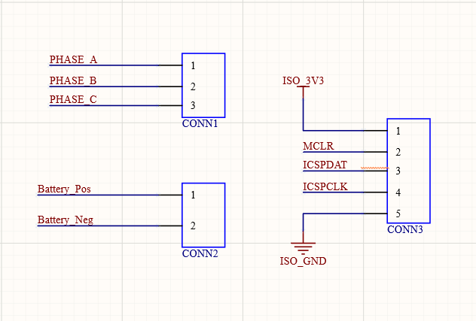

Figure 22 Connector Schematic

To sum up the schematic design, we have designed our circuit in detail by investigating and exploring all of the datasheets deeply. We have considered needed bypass capacitors, diodes, pull-down resistors, and other equipment. We will carry this detailed work into PCB works to achieve best design.

# PCB Design

## Rules and Validations

After concluding our simulation report and feedback session, we have made some corrections on component selection and schematic design, which is discussed above, then we moved into PCB design part. As we stated before, our main idea is to have a compact, reliable, adjustable, and high power dense electronic card, so we have counted these features during design process.

In this project, we have used Altium Designer 20, and our design has two layers, and both layers include components. Before starting our design, we have determined the design rules to have a reliable and safe card, which can be seen in Figure 23. However, for medium voltages (150-300V), according to IPC2221A, clearance between lines should be minimum 1.25mm, for our medium voltage tracks (rectifier), we have used that minimum value. For 15V and 30V range, this spacing should be minimum 0.25mm, where our clearance rule satisfies that value.

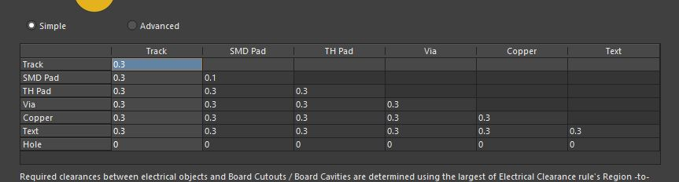

Figure 23 PCB Design Rule (Clearance)

From simulations, we have seen that, in rectifier and buck converter, we have a maximum 2.5A current, and our lines and vias should satisfy this value. For rectifier and buck converter lines, we used fixed 0.8mm line width, and minimum 0.6mm via hole, 1,2mm via pad to stay in safe zone. For other low current lines, we have used various line width between 0.3mm and 0.5mm, and we used fixed via dimensions which are 0.4mm hole and 0.8mm pad. We have validated rectifier line and via ratings from Saturn PCB Toolkit, which can be seen in Figure 24 and 25, respectively.

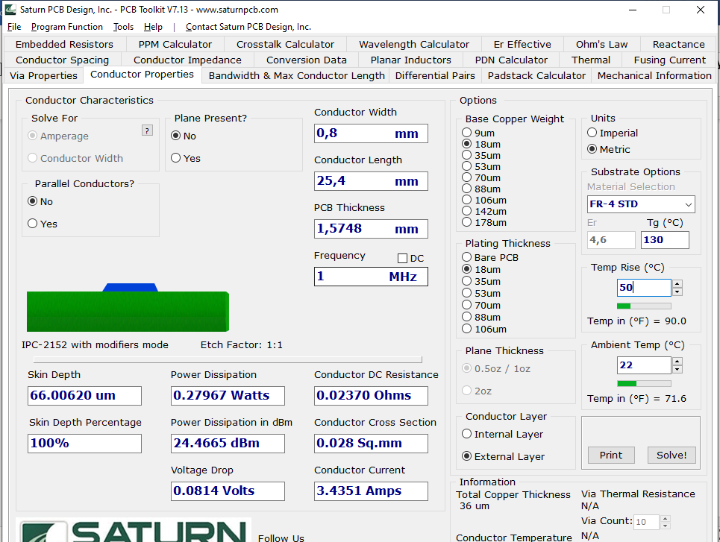

Figure 24 Line Current Validation

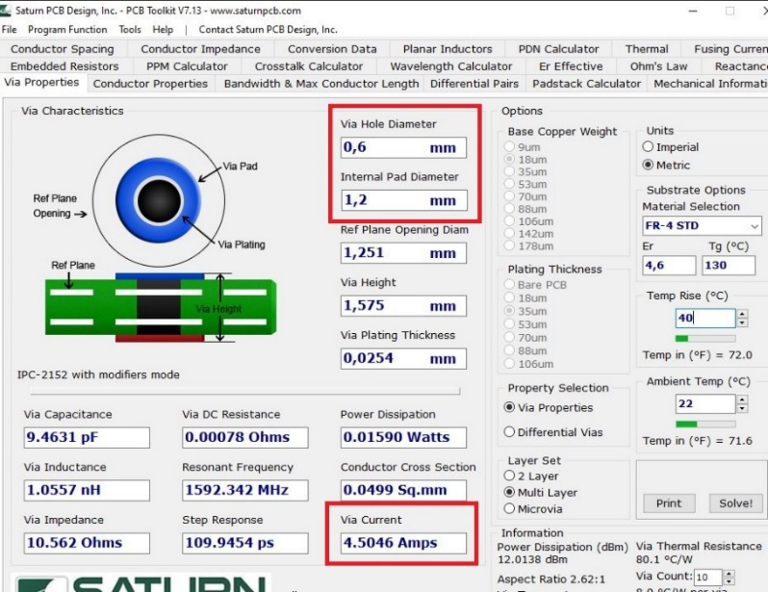

Figure 25 Via Current Validation

After finalizing our rules and getting validation for our pre-design about lines and vias, we have constructed our PCB design, and when we finalized that design, we used the Design Rule Check of Altium Designer, to see violations and connection problems. And finally, we have achieved a card without any error, which can be seen in Figure 26.

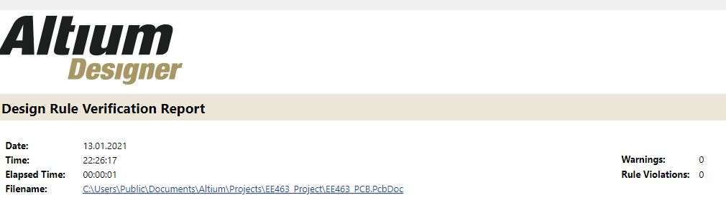

Figure 26 Design Rule Check

## 2D Design

In order to have a small, compact and a useful design, we have placed our components to both layers. Generally, we have placed the isolated part into bottom layer (digital components), because we have used a lot of vias in this section of the board, and if we did this in rectifier or buck converter part, it would be problematic due to high currents, for vias. Overall view of our PCB design can be seen in Figure 27.

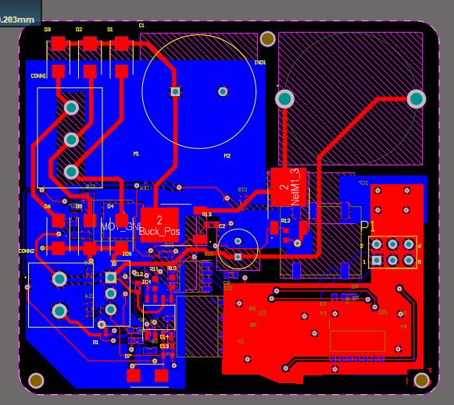

Figure 27 Overall PCB Design

As we mentioned before, we have arranged medium voltage (300V), clearance as 1.25mm minimum, and for other lines we have used clearance of Design Rule, which is 0.3mm. Moreover, according to IPC rules, difference between PCB pad and line/device pad should be minimum 0.4mm, we have applied that rule, too.

If we look to placements of our components on board, we will firstly investigate rectifier and buck converter components. In this part, we have biggest components on the board. Moreover, heatsinks of MOSFET’s have taken a lot of space on board, however our heatsink places on the DPAK MOSFET, and wings of the heatsink placed with offset from board, so we have placed some of the small components under these wings, which helped us to decrease the dimension of the board. Rectifier and buck converter component placement can be seen in Figure 28.

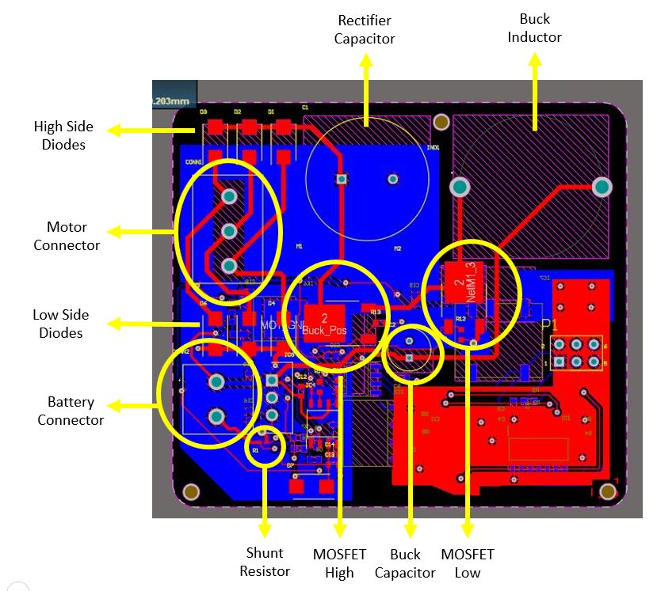

Figure 28 Rectifier and Buck Converter Placement on PCB

In component placement, we will secondly investigate isolation boundary and digital part of our design. According to the datasheet, we should not take any line from the bottom of the isolator, however, placing a thin ground plane would not be problematic, as we did. We have left enough space between MOT_GND and ISO_GND, which are our grounds for motor side, and digital side, respectively. Placement of digital components, isolation boundary and planes of board can be seen in Figure 29.

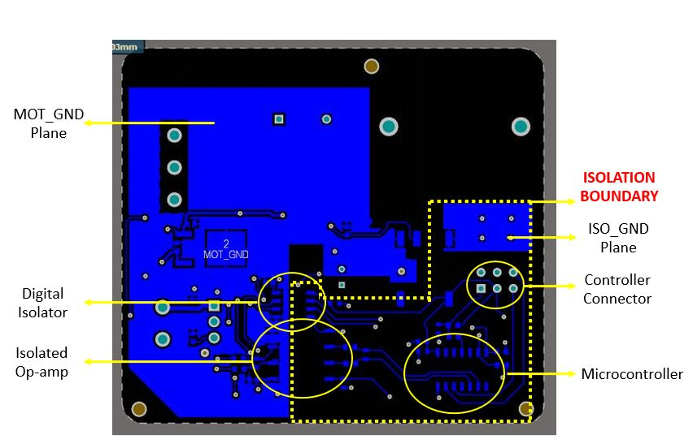

Figure 29 Isolation and Digital Component Placement on PCB

Thirdly, we will investigate power conversion units of our design. 24V/12V and 24V/3V3 components are placed close to Battery Connector, and 3V3 Isolator placed between isolation boundary, and ground pins are connected to corresponding ground, which has given to us a reference boundary distance. Placement of power conversion units can be seen in Figure 30.

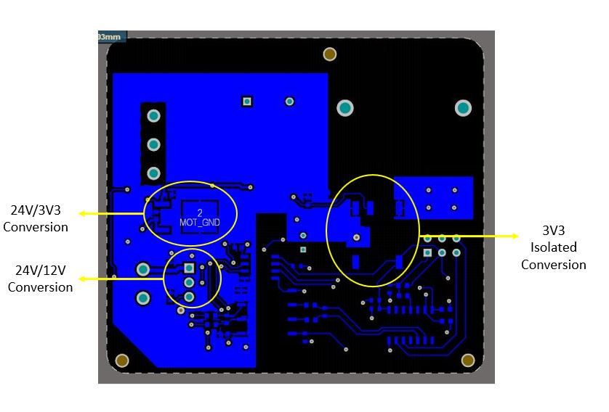

Figure 30 Power Conversion Component Placement on PCB

Lastly, we will investigate gate driver and mechanical connection placement. We have placed our gate driver near to 24V/12V converter because we use 12V only in our gate driver. We have placed metric-2 fiducials, in order to immobilize our design in a box. Gate driver and fiducial placement can be seen in Figure 31.

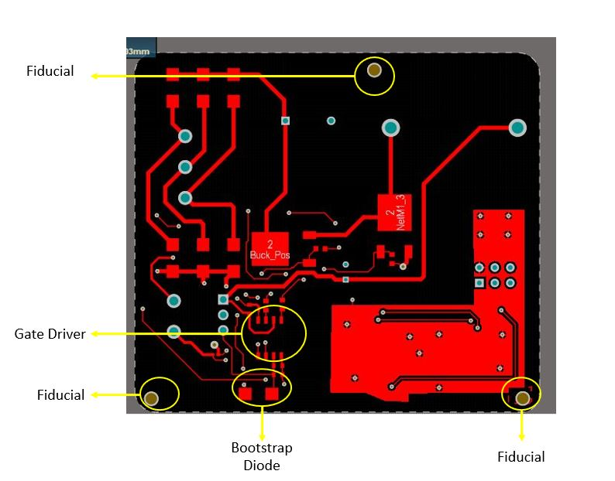

Figure 31Gate Driver and Fiducial Placement on PCB

We have investigated component placement (except discrete capacitor and resistors) on our PCB for 2D design. In 2D, we will lastly investigate dimensions of our board. As we mentioned before, we have placed our components both of the layers, and we have placed some of the small components under heatsink trace, to have a small and dense design. Moreover, we have constructed our design by obeying clearance rules in order to have a safe and reliable product. At last, we have a card with **66.5mm X 59mm** dimensions. In Figure 32, card dimensions can be seen.

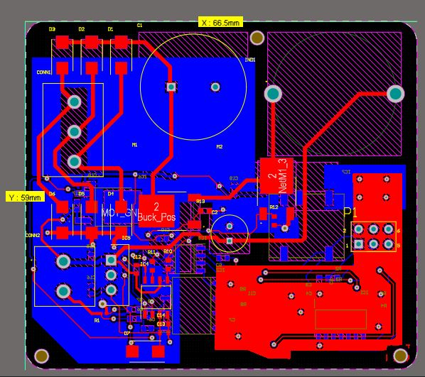

Figure 32 Board Dimensions

## 3D Design

To have a reliable and professional design, we have placed 3D designs of our components to our component PCB library. Moreover, by constructing 3D design, now we are ready to select/design box for our board, which shows us that our design is an industrial product. Top view, bottom view and side view of our PCB design can be seen in Figure 33, 34 and 35, respectively.

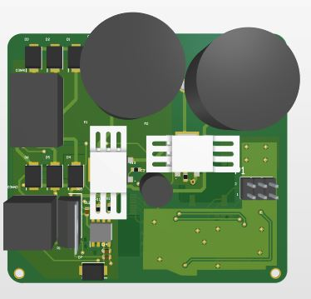

Figure 33Top View of 3D PCB Design

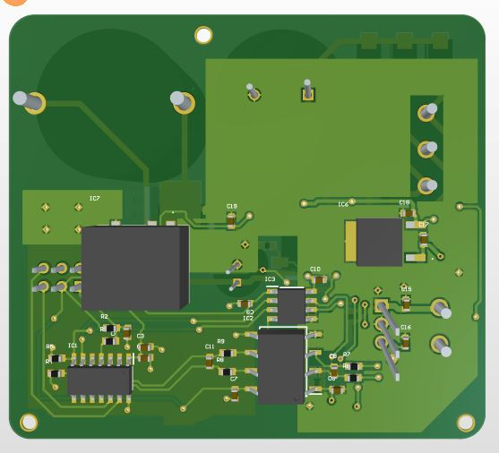

Figure 34Bottom View of 3D PCB Design

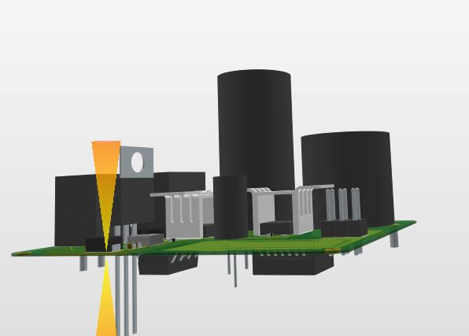

Figure 35 Side View of 3D PCB Design

We gave shown our component placement in 2D design part, however realizing these components in 3D, and comparing with 2D explanations could give a better understanding of our design. Component placement on 3D model for top and bottom layer can be seen in figure 36 and 37, respectively.

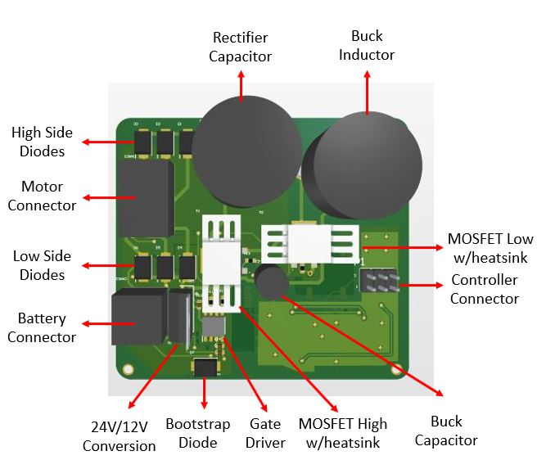

Figure 36 Top Layer Component Placement for 3D

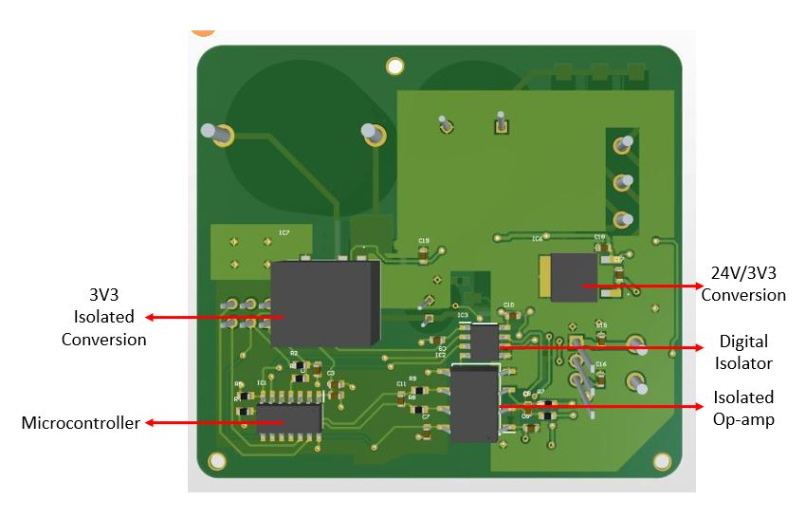

Figure 37 Bottom Layer Component Placement for 3D

At the beginning of the PCB design report, we have discussed the current ratings of our circuit, and used 18um Base Copper Weight and 18um Plating Thickness, which sum up to 1 oz Cu, in our 2-layer circuit. To have a reliable card, we will use 1.6mm card thickness. We will use the card material FR-4 because, compared to Aluminum one FR-4 is more efficient because conduction loss of Copper is lower than conduction loss of Aluminum. Moreover, due to material of FR-4 it is more resistive to water exposure. To have a low price, we will select transition temperature (TG) as 130-140.

At the top layer, the rectifier capacitor has the maximum length. When we look datasheet of ESH series, we see a list for size codes and our capacitor’s code is N2, which means our longest component on top layer is 38mm, including tolerance. When we look bottom layer, the 3V3 isolator has the maximum length, which is 6mm, including tolerance. As we discussed, our board thickness is 1.6mm and if we put 10mm tolerance for box for soldering or screwing, our total box vertical length will be 55.6mm. In 2D Design section, we have stated our board’s horizontal dimensions as 59mm X 66.5mm and if we put 10mm margin for both X and Y axes to place our board into box correctly, **total dimensions of our box will be 69mm X 76.5mm X 55.6mm.** Which means, **total volume of our industrial product is 293484.6 .**

## Conclusion of PCB Design

In this part of the report, we firstly discussed rules and validations to prove reliability of our design. Then, we have discussed and explained our 2D design, by referring component placement, isolation boundary and fiducials. Lastly, we have shown our 3D design and explained component locations. Moreover, we have discussed board parameters and lastly, we have designed our box dimensions and calculated volume of our design.

In PCB design, we believe that we are tried to work as a professional by considering all of the possible problems (line spacing, line width, via hole dimension, isolation boundary, copper thickness etc.). And we believe that, we have created a usable (programmable for different current ratings), reliable and compact design.

# Conclusion

In this project, the aim is showing the outcomes of the lecture in practical level. We have considered a real case, which is a rising phenomenon in energy industry, the Wind Turbines.

We have made a circuit design which rectifies the three-phase AC voltage, reduces it to charge a battery in desired value and controls it with closed feedback loop. Then, we made the necessary simulation with the selected component parameters based on the Simulation Report. In here the idea is, simulation is a tool for specifying the components in order to design a reliable and compact product. Then according to selected components voltage and current ratings, we have calculated the losses in the circuit to see which components can be problem in terms of heat and how we should use the heat sinks. When the components are decided for certain, we prepare a BOM list to see how much money we should pay for one circuit when we order for 1000 circuitry. **It cost for around 17 $ per circuit.**

At the las part, we draw the schematics of our components and subsystems by using a design tool Altium. Then, we designed our PCB card as small as possible to save space. This is an important part in order to see the component as a circuit particle, not a simulation box.

During the project process, we have learnt lots of thing for the EE463 lecture and also for application of the circuits in real life. We have faced for many struggles like simulation errors, indecision to select components whether we should consider the money or the stability of the circuit etc, and the time problem due to conditions and intensity of the period. We tried to do our best to overcome these problems. But in the end, we believe that we produced a good job in this semester, and we feel like we get closer one step to become Power Electronics Engineers.

# References

|  |  |
| --- | --- |
| [1] | B. Hauke, «Basic Calculation of a Buck Converter's Power Stage,» Texas Instruments Inc., 2015. |
| [2] | M. Score, «Ceramic or electrolytic output capacitors in DC/DC converters—Why not both?,» *Analog Applications Journal,* pp. 16-20, 2015. |
| [3] | A. KARAFIL ve H. OZBAY, «Power Control of Single Phase Active Rectifier,» *BALKAN JOURNAL OF ELECTRICAL & COMPUTER ENGINEERING,* pp. 332-336, 2019. |
| [4] | «TOLERANCES ON COPPER THICKNESS,» 2020. [Online]. Available: https://www.eurocircuits.com/tolerances-on-copper-thickness/. |
| [5] | L. Rozenblat, «CALCULATING SPACING BETWEEN PCB TRACES FOR VARIOUS VOLTAGE LEVELS,» 2014. [Online]. Available: https://www.smps.us/pcbtracespacing.html. |
| [6] | PCBway, «Aluminum PCB vs FR-4 PCB,» 28 February 2018. [Online]. Available: https://www.pcbway.com/blog/Engineering_Technical/Aluminum_PCB_vs_FR_4_PCB.html. |